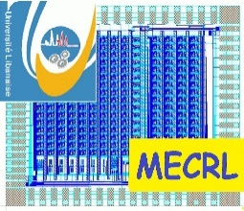 | 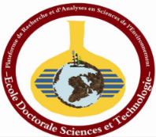

Lebanese University
Doctorate School of Science & Technology - EDST
Platform for Research and Analysis in Environmental Sciences - PRASE
MECRL TEAM

Ph.D. applications 2023-2024

The MECRL at PRASE – EDST Lebanese University announces a Ph.D scholarship possibility for applications 2023-2024 in cooperation with Genoa University (Italy). The candidates’ competencies must be in Electronics, Computer Engineering, Bioengineering, Robotics, Communication and Networking.

MECRL at PRASE – EDST invites highly motivated students interested to participate in the Ph.D. program to submit application form, CV, two recommendations letters, thesis summary and the grades (from baccalaureate to M2R including raking in class) to the following email fatima.nasser@ul.edu.lb from 27 March to 27 April 2023.

Selected students who meet all the requirements must therefore submit their applications for a public Ph.D exam in Italy, prepare a research proposal and pass an interview on Skype, in order get the possibility to obtain a Ph.D scholarship.

